**ASSIGNMENT 2**

**SDK MANAGER:**

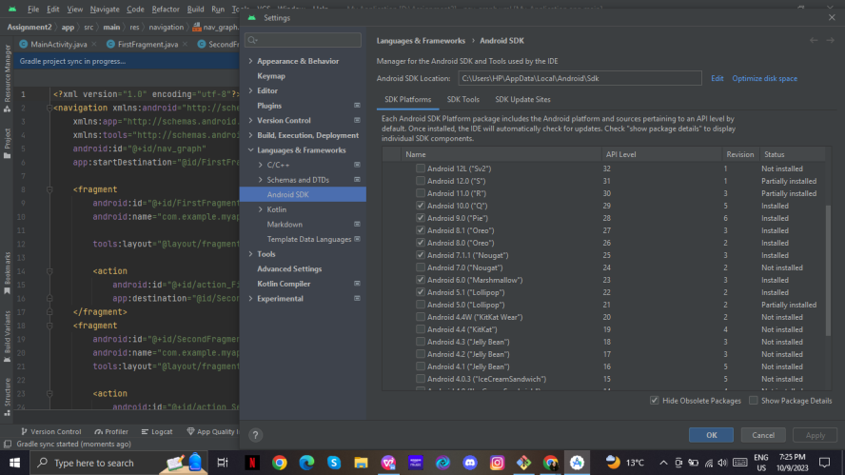

*Fig: This screenshot shows the SDK manager*

**DEVICE Manager:**

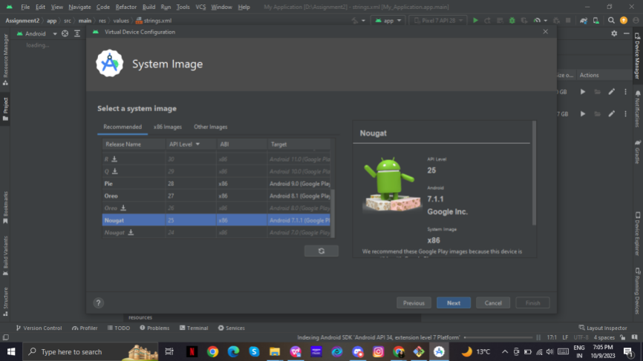

*Fig: Creating a new virtual device with API level 25*

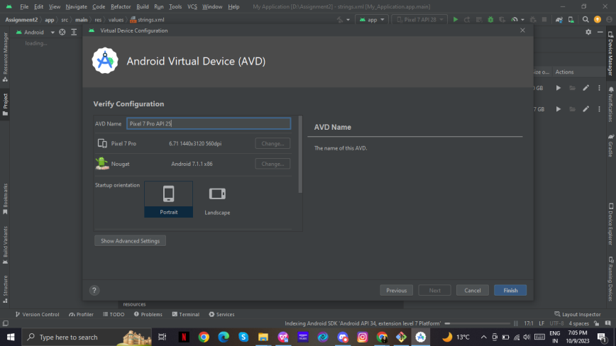

*Fig: The name of the app shows the device model and API level*

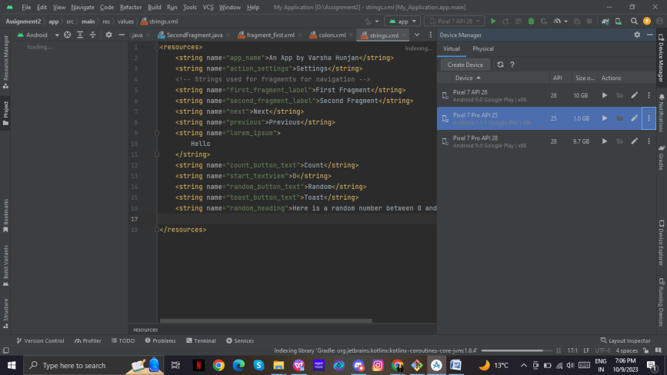

*Fig: We can see the created device*

**The code of the app:**

**Gradle files:**

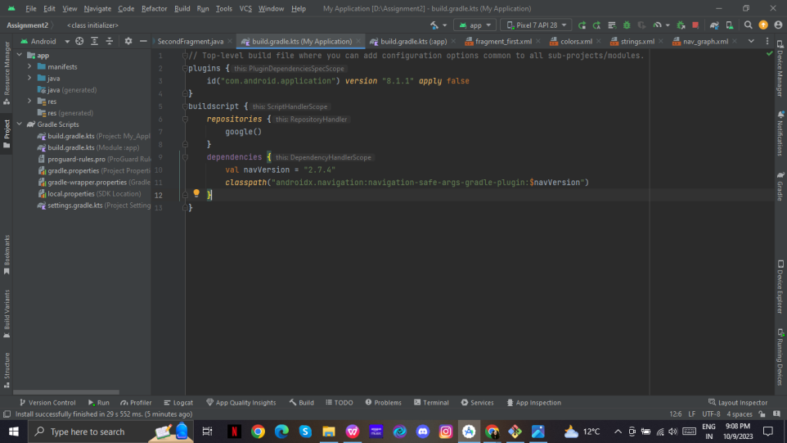

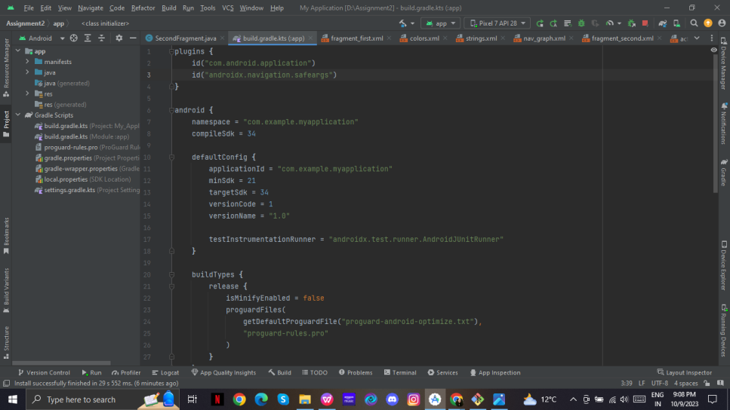

This app has two fragments. First fragment and second fragment

First Fragment:

In this fragment, there are three buttons and a textview. The textview displays 0 by default and increases the number if count is pressed. Toast button shows a small toast message and Random button passes the value of count to next page and displays a random number between 0 and count on second screen.

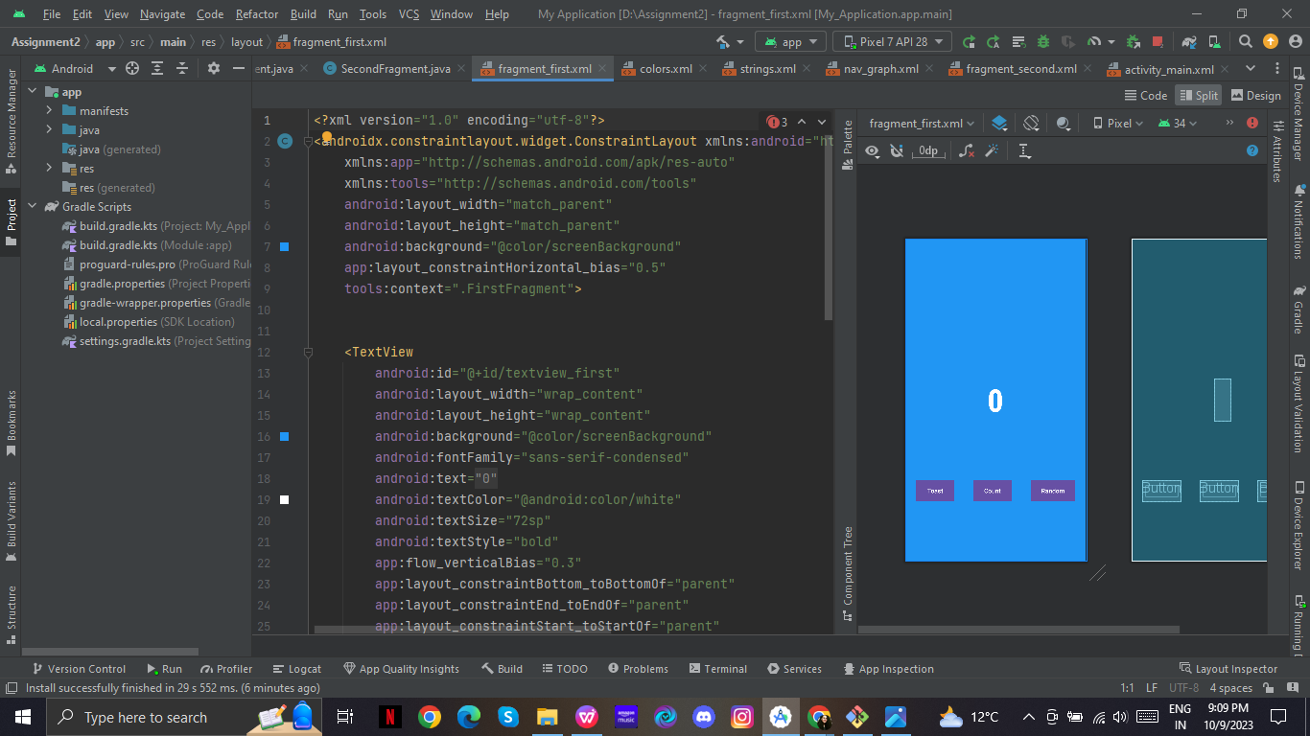

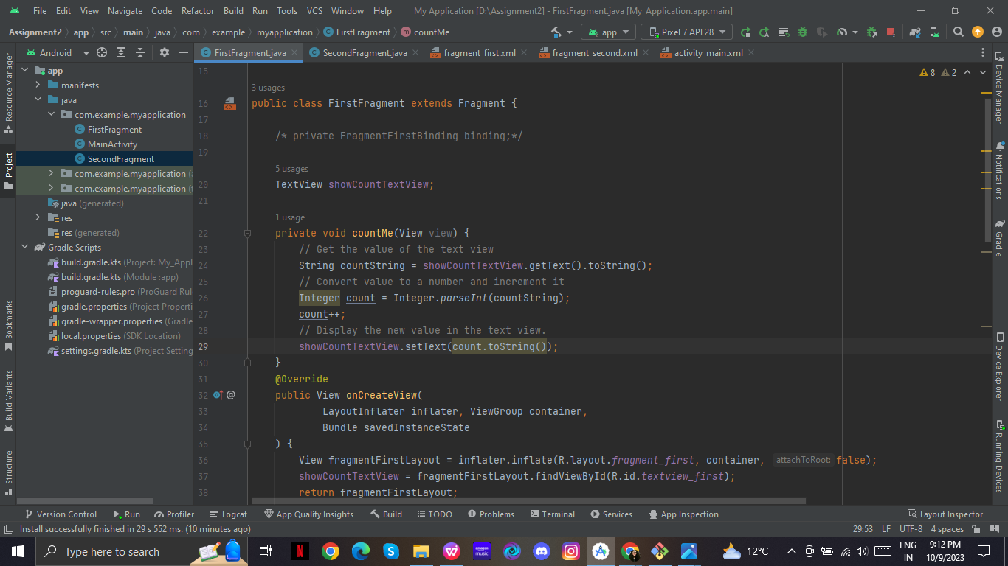

Second Fragment:

This fragment has 2 textviews and a button. First textview displays and sentence and the second textview displays a random number between 0 and count(value taken from fragment 1). Previous button takes us back to the first fragment.

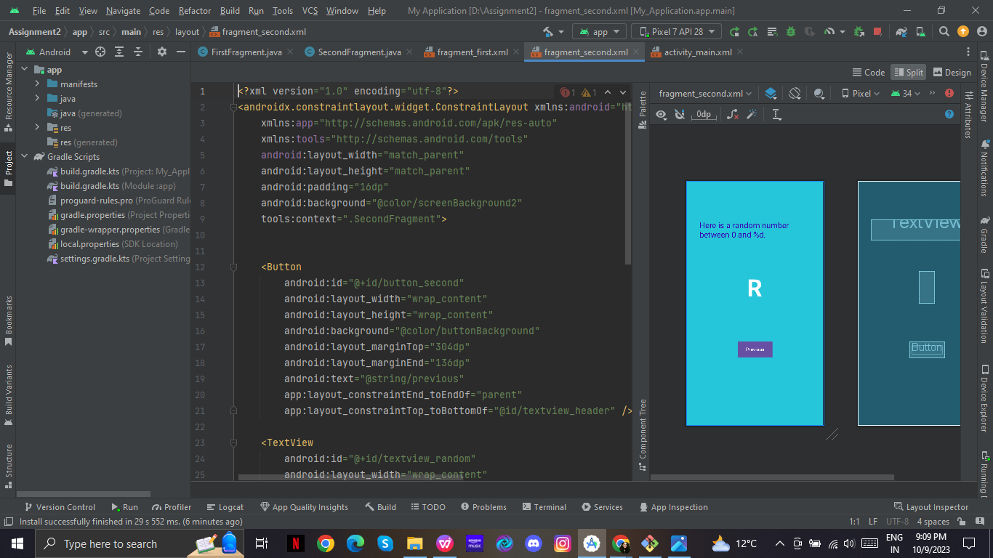

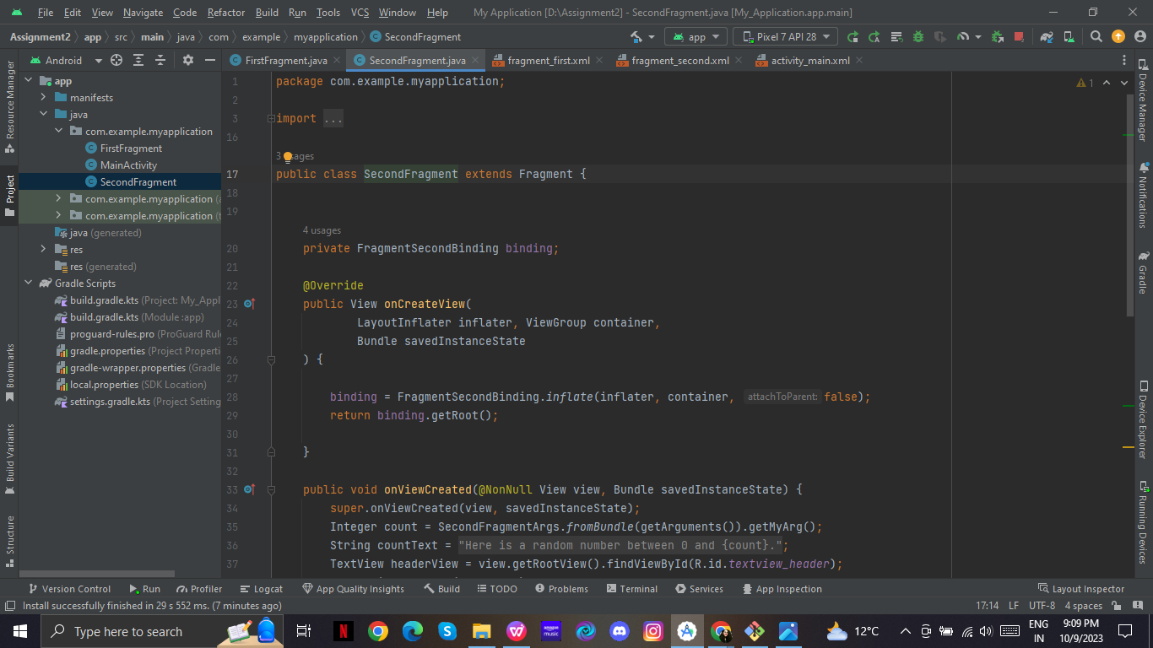

**PUSHING FILES TO GITHUB**

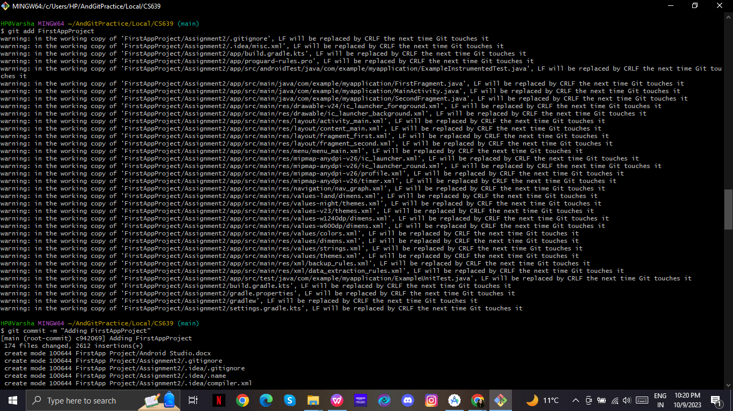

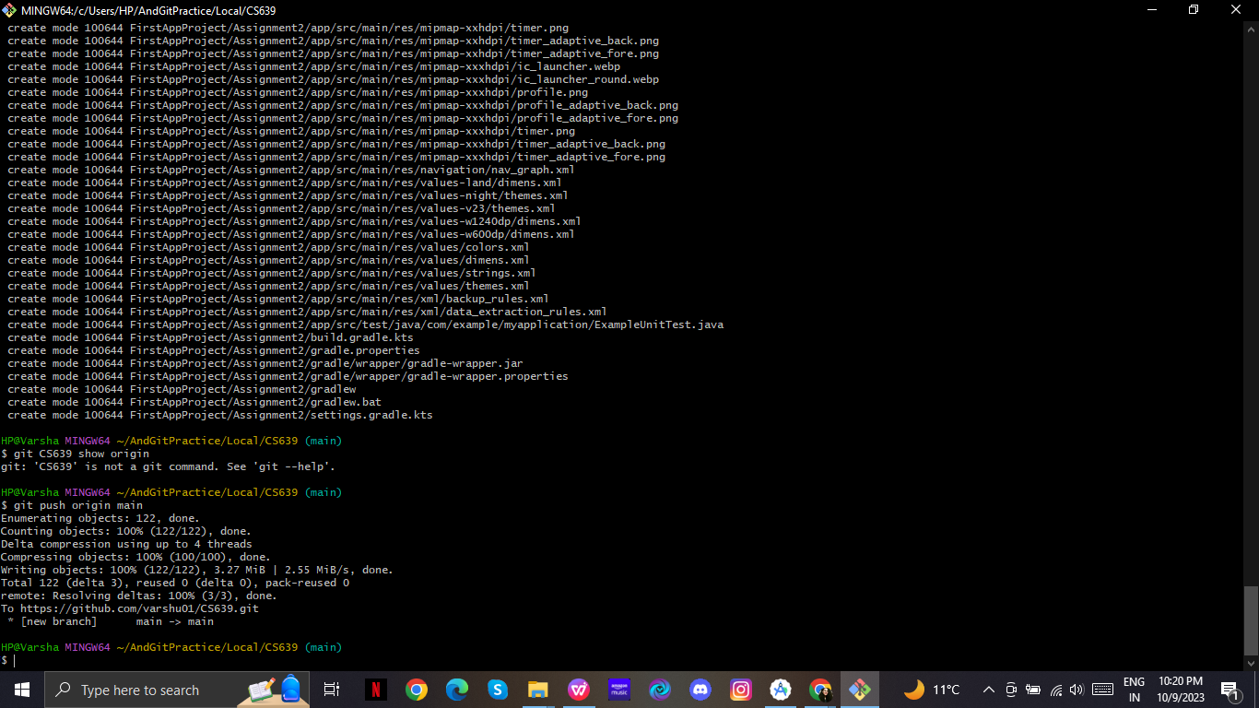

**TESTING:**

**Working of app on Android device**

(Android Version 12)

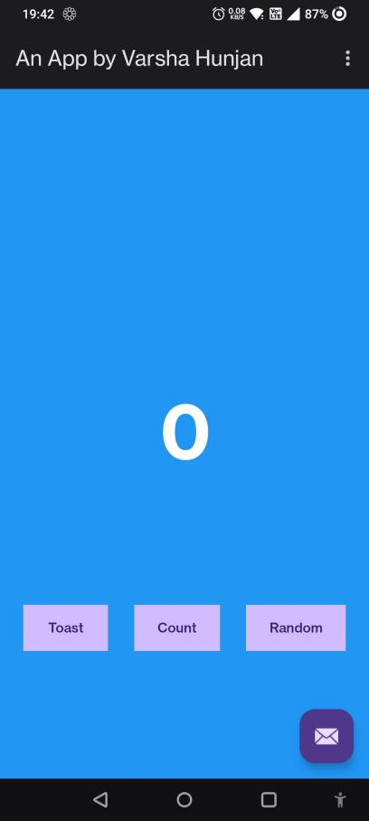  
*Fig: This is the start / first screen on the app*

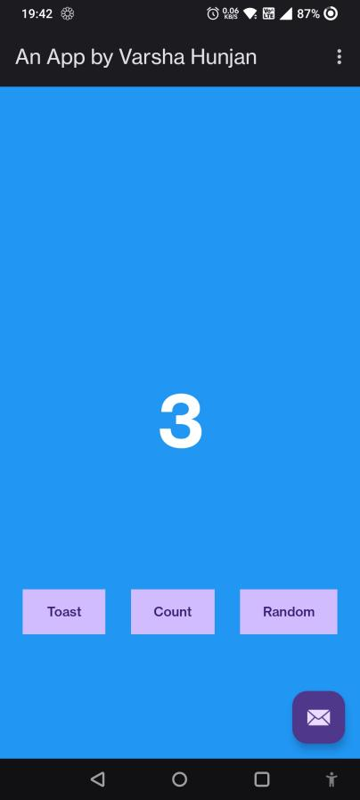  
*Fig: If we press the count button, the count displayed on the screen increases*

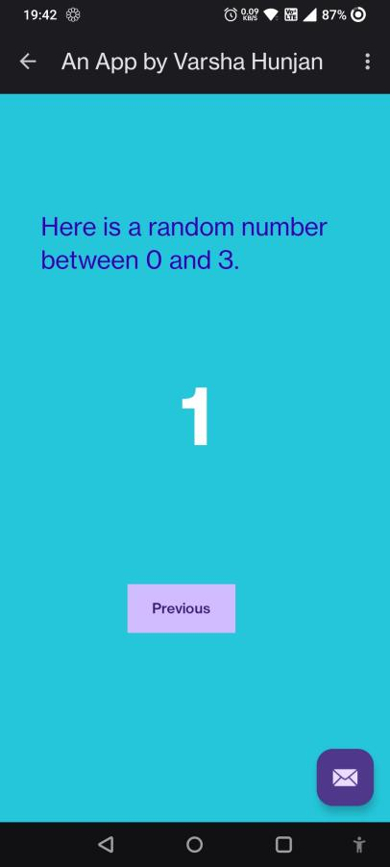  
*Fig: If we press the Random button on first screen, it shows a random number between 0 and the current count.*

*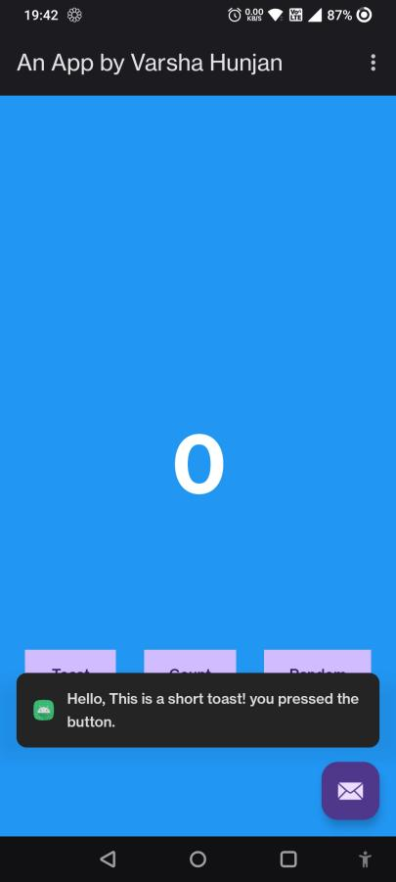  
Fig: If we press Toast button, the following toast message is shown*

**AVD Manager Test**

**Testing on virtual device with API 25  
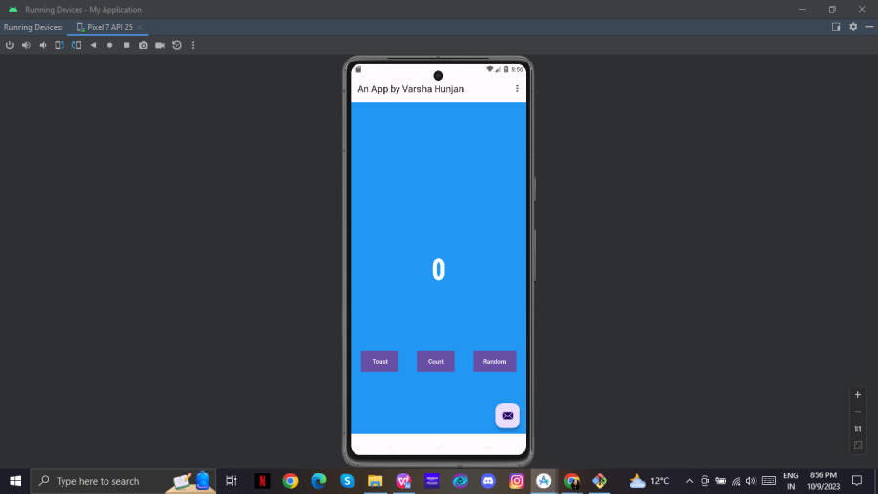**

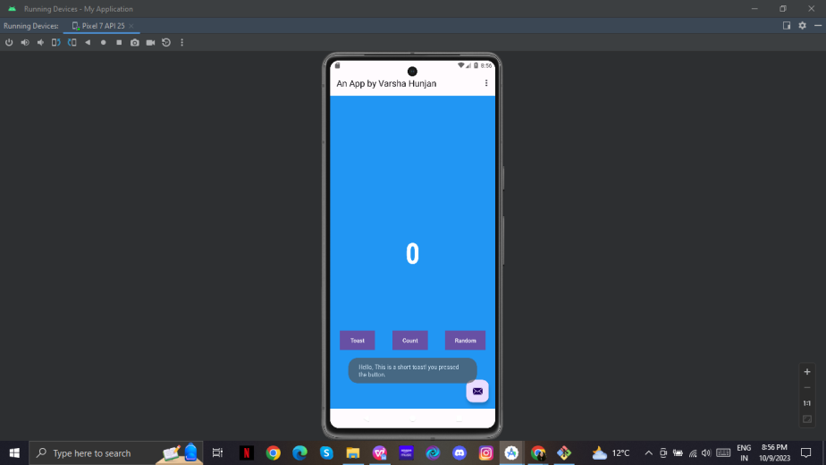

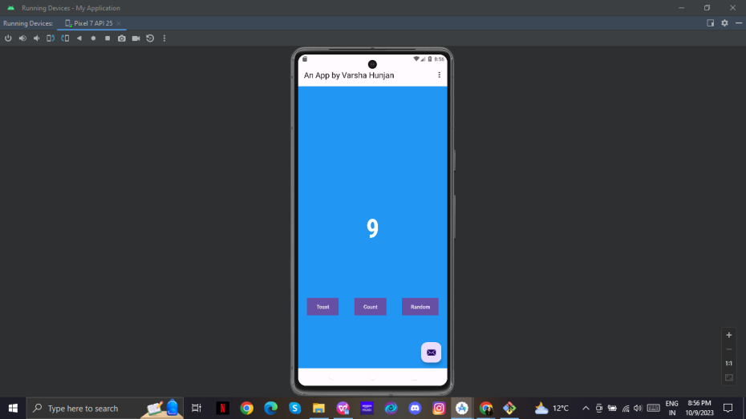

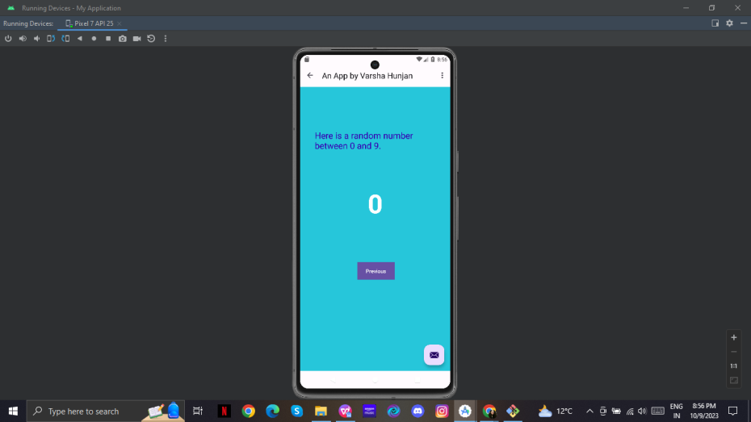

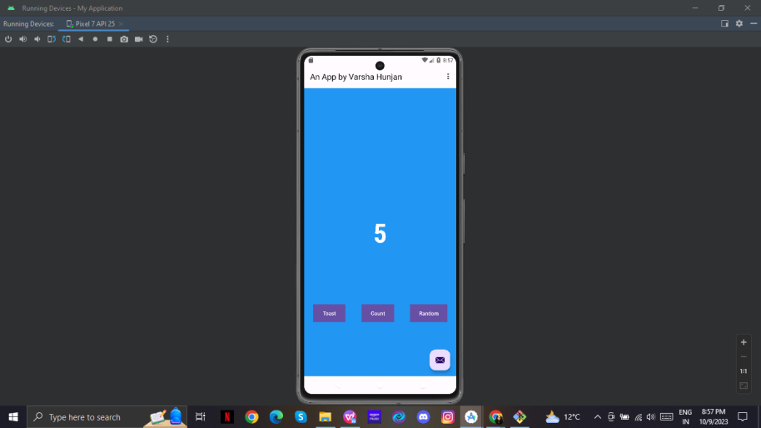

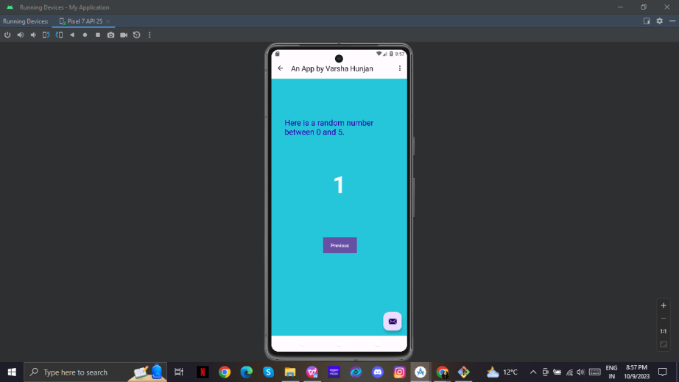

**Testing on virtual device with API level 28**

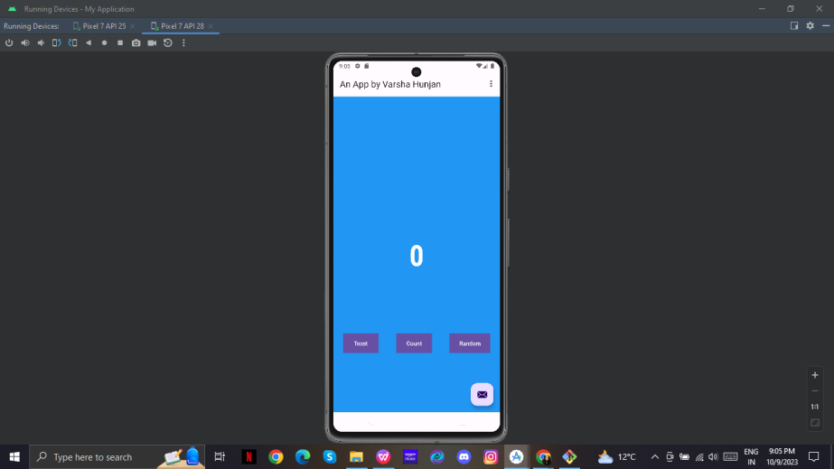

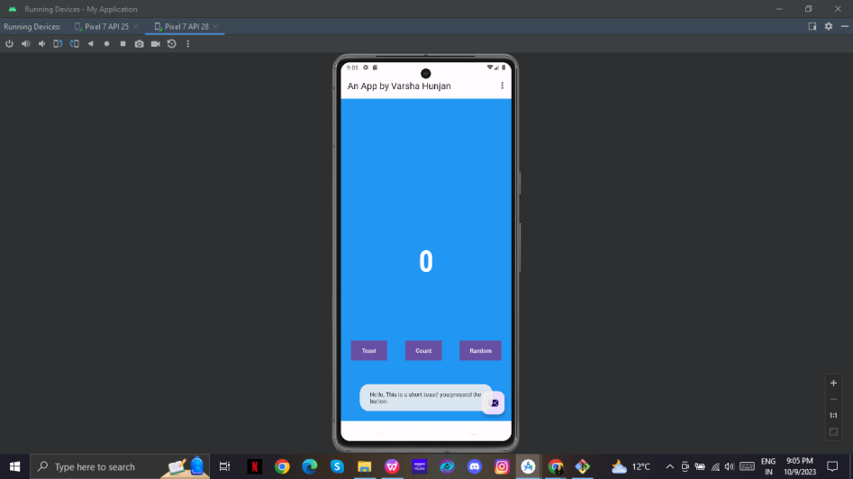

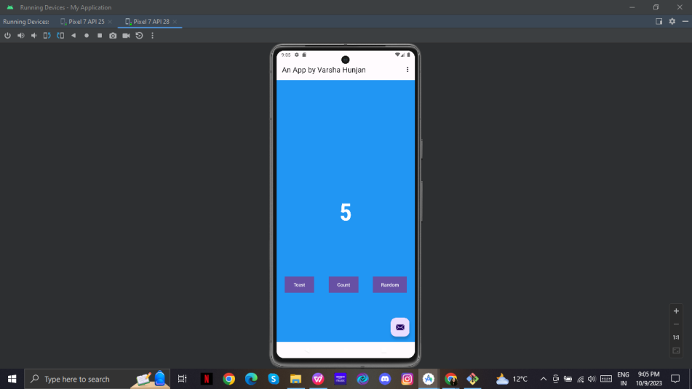

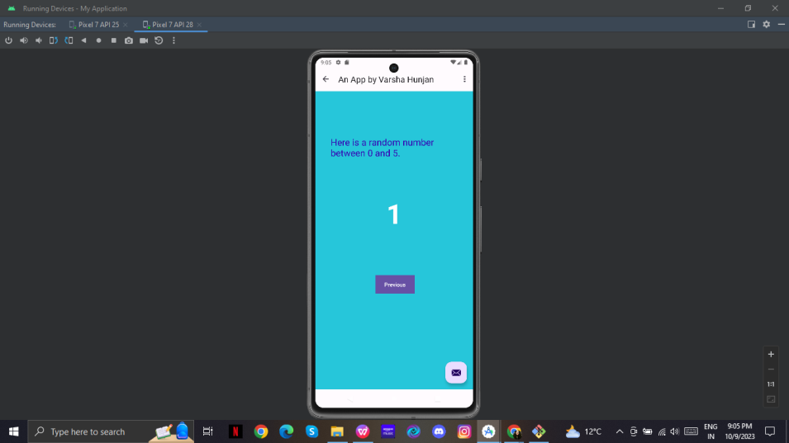

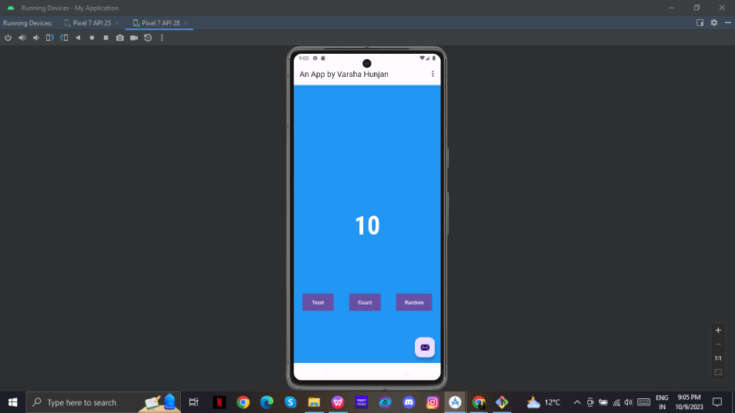

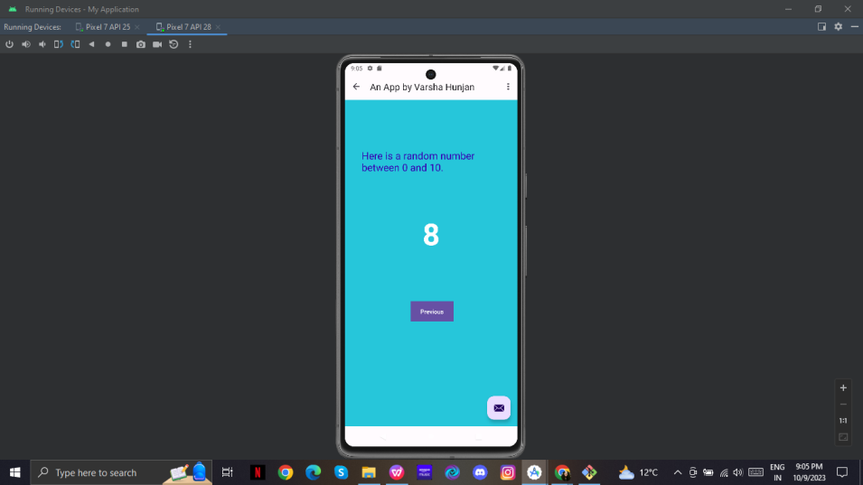

**ADDING IMAGES TO THE PROJECT**

**Included first image named timer to the project**

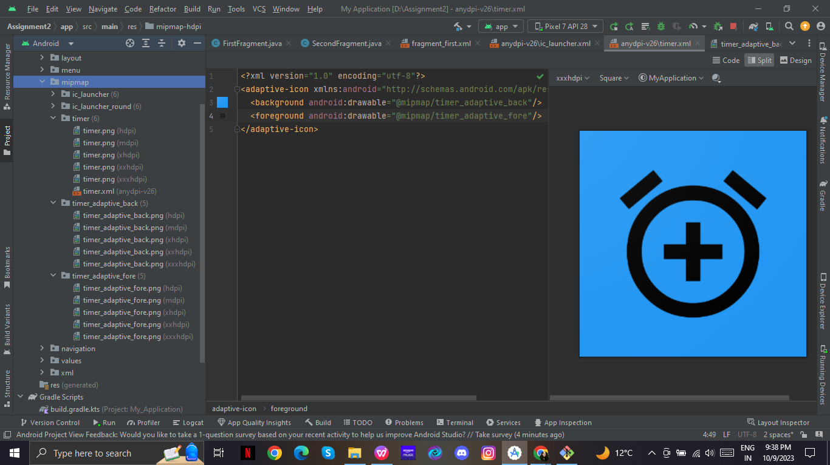

**Included second image named profile to the project**

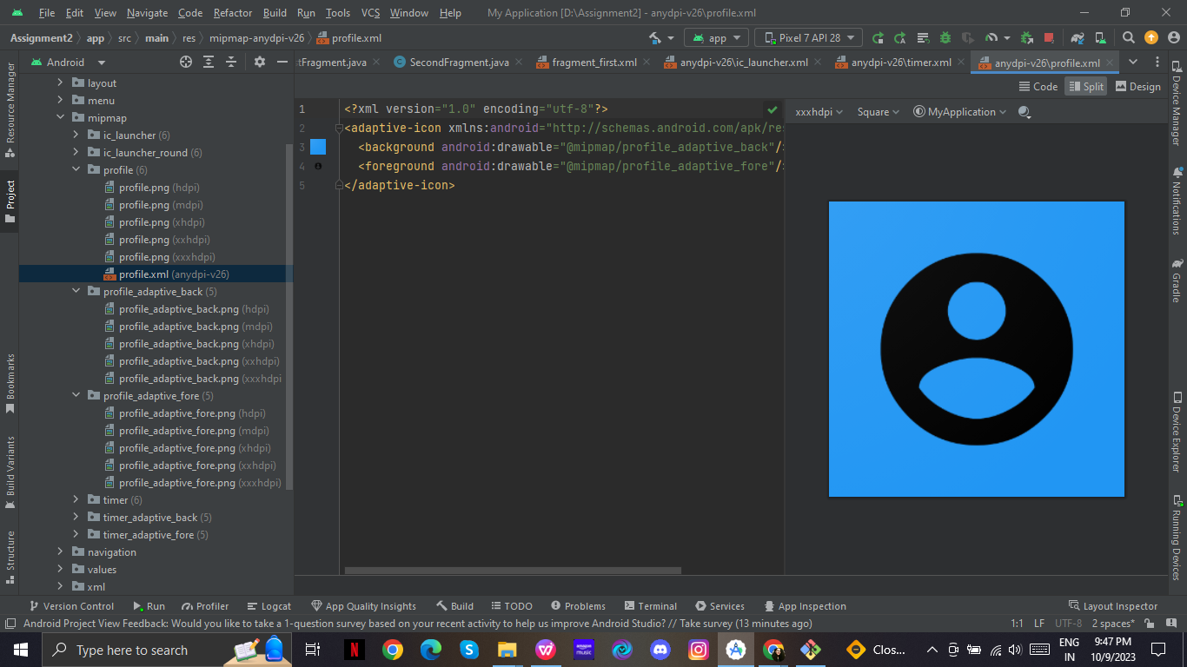

**Added the image profile as Image view**

